React Tutorial Part 01
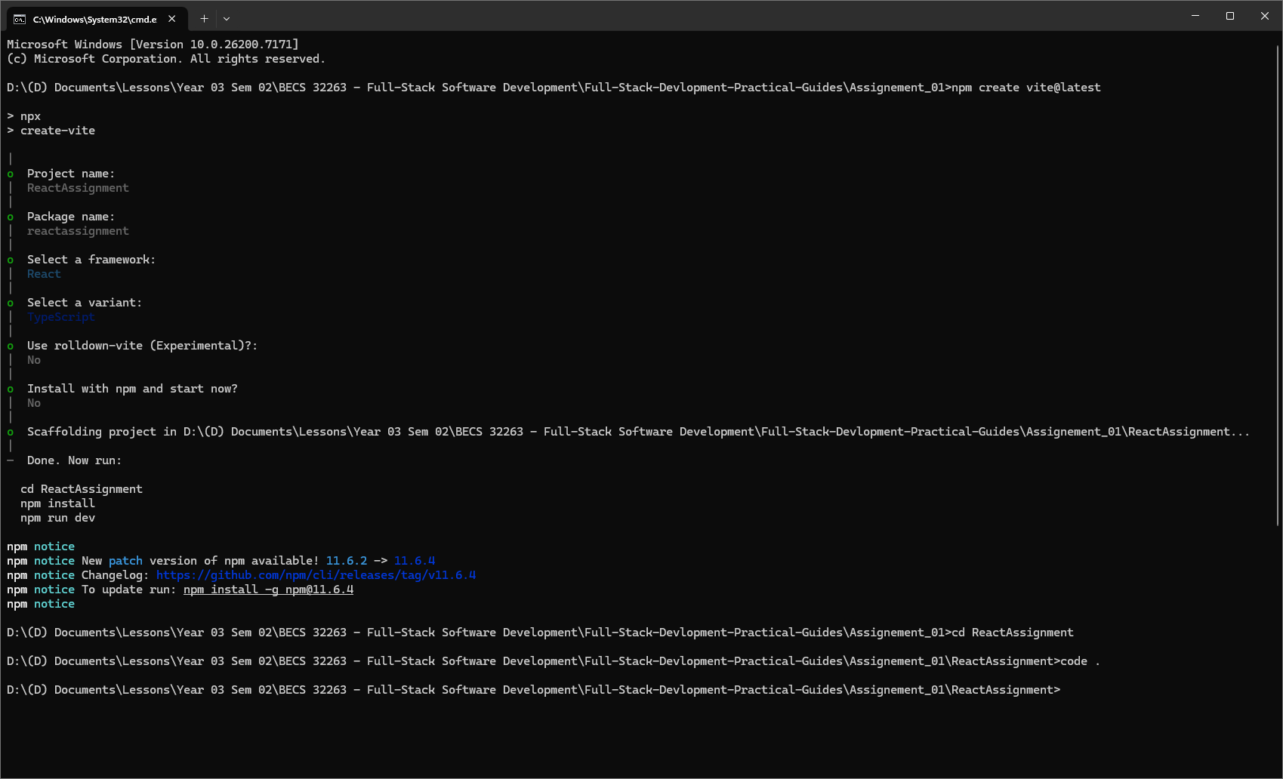
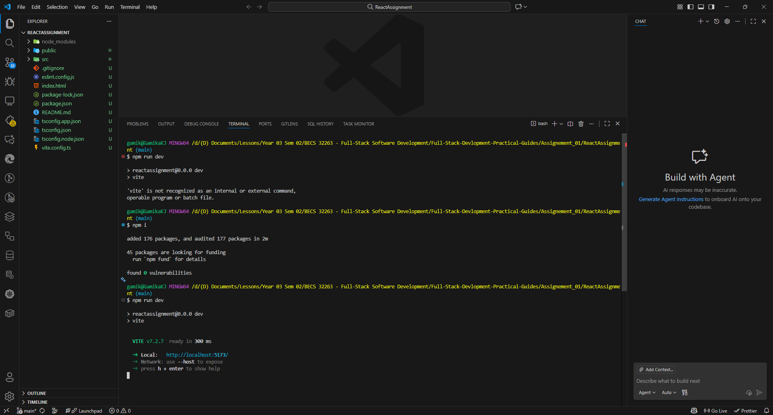
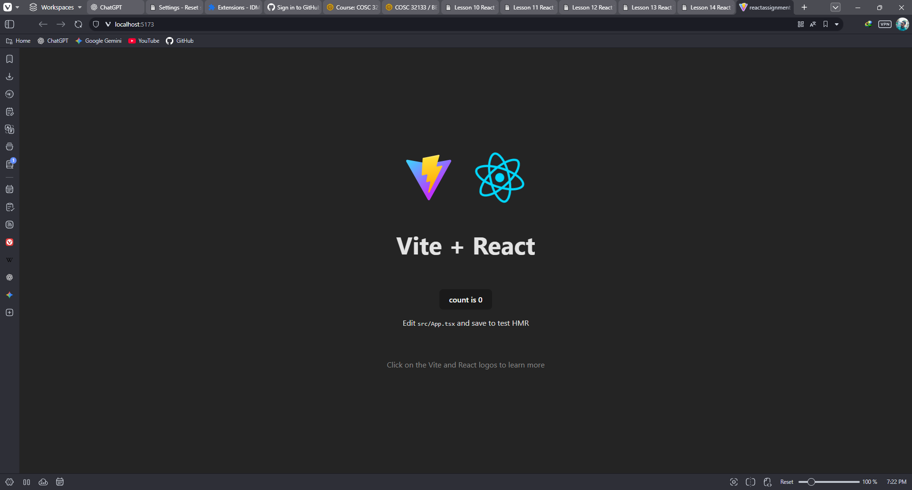
function HelloWorld(){
const UOK = "UOK";
return <h1>Hello World!</h1>;
};
export default HelloWorld;

import HelloWorld from "./HelloWorld"

function App() {
return (
<>
<HelloWorld />
</>
)
}

export default App

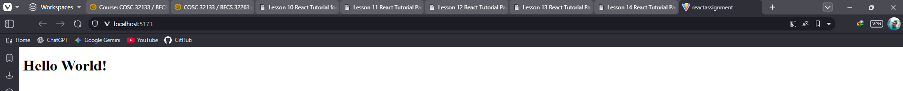

React Tutorial Part 02
import React from "react";
const ListGroup: React.FC = () => {
const cities: string[] = ["Colombo", "Kandy", "Galle"];
return (
<>
<h3>Cities in Sri Lanka</h3>
<ul className="list-group">
{cities.map((city, index) => (
<li key={index} className="list-group-item">
{city}
</li>
))}
</ul>
</>
);
};
export default ListGroup;

import React from 'react';
import ListGroup from './components/ListGroup';

const App: React.FC = () => {
return (
<div>
<ListGroup />
</div>
);
};
export default App;

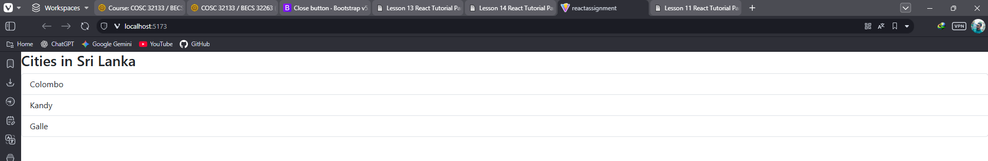

import React from "react";
const ListGroup: React.FC = () => {
const cities: string[] = ["Colombo", "Kandy", "Galle"];
return (
<>
<h3>Cities in Sri Lanka</h3>
{cities.length === 0 ? (
<p>No cities available.</p>
) : (
<ul className="list-group">
{cities.map((city, index) => (
<li key={index} className="list-group-item">
{city}
</li>
))}
</ul>
)}
</>
);
};
export default ListGroup;

import React from "react";
const ListGroup: React.FC = () => {
const cities: string[] = [];
//"Colombo", "Kandy", "Galle"
return (
<>
<h3>Cities in Sri Lanka</h3>
{cities.length === 0 ? (
<p>No cities available.</p>
) : (
<ul className="list-group">
{cities.map((city, index) => (
<li
key={index}
className="list-group-item"
onClick={() => console.log(index)}
>
{city}
</li>
))}
</ul>
)}
</>
);
};
export default ListGroup;

import React from "react";
const ListGroup: React.FC = () => {
const cities: string[] = ["Colombo", "Kandy", "Galle"];
const handleClick = (
event: React.MouseEvent<HTMLLIElement>,
index: number
) => {
console.log(`City index: ${index}`, event);
};

return (
<>
<h3>Cities in Sri Lanka</h3>
{cities.length === 0 ? (
<p>No cities available.</p>
) : (
<ul className="list-group">
{cities.map((city, index) => (
<li
key={index}
className="list-group-item"
onClick={(e) => handleClick(e, index)}
>
{city}
</li>
))}
</ul>
)}
</>
);
};
export default ListGroup;

import React, { useState } from 'react';
const ListGroup: React.FC = () => {
const cities = ["Colombo", "Kandy", "Galle"];
const [selectedIndex, setSelectedIndex] = useState<number | null>(null);
return (
<ul className="list-group">
{cities.map((city, index) => (
<li
key={index}
className={`list-group-item ${
selectedIndex === index ? "active" : ""
}`}
onClick={() => setSelectedIndex(index)}
>
{city}
</li>
))}
</ul>
);
};
export default ListGroup;

import React, { useState } from 'react';
const ListGroup: React.FC = () => {
const cities = ["Colombo", "Kandy", "Galle"];
const [selectedIndex, setSelectedIndex] = useState<number | null>(null);
return (
<ul className="list-group">
{cities.map((city, index) => (
<li
key={index}
className={`list-group-item ${
selectedIndex === index ? "active" : ""
}`}
onClick={() => setSelectedIndex(index)}
>
{city}
</li>
))}
</ul>
);
};
export default ListGroup;

import React from 'react';
import ListGroup from './components/ListGroup';

const App: React.FC = () => {
return (
<div>
<ListGroup />
<ListGroup />
</div>
);
};
export default App;

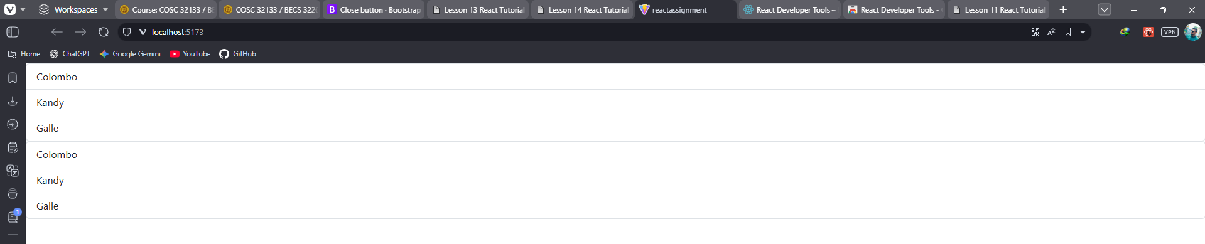
interface ListGroupProps {
heading: string;
items: string[];
}
const ListGroup: React.FC<ListGroupProps> = ({ heading, items }) => {
return (
<>
<h3>{heading}</h3>
<ul className="list-group">
{items.map((item, index) => (
<li key={index} className="list-group-item">
{item}
</li>
))}
</ul>
</>
);
};
export default ListGroup;

import ListGroup from './components/ListGroup';

const App = () => {
const cities = ["Colombo", "Kandy", "Galle"];
return <ListGroup heading="City List" items={cities} />;
};
export default App;

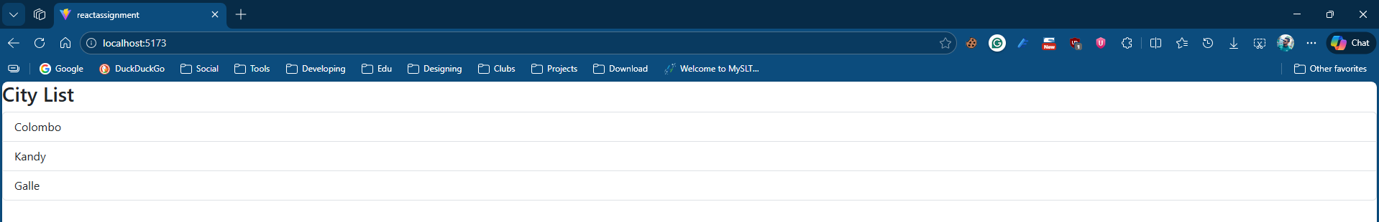

React Tutorial Part 03
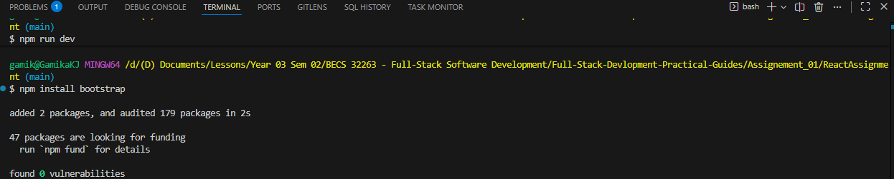
import React from 'react';
interface HiProps {
children: React.ReactNode; // Accept any valid React node
}
const Hi: React.FC<HiProps> = ({ children }) => {
return (
<div>
{children}
</div>
);
};

export default Hi;

import React from 'react';
import Hi from './components/Hi';

const App: React.FC = () => {
return (
<div>
<Hi>
<h3>Welcome to the React Tutorial</h3>
<p>This is a reusable component with custom HTML
content passed as children!</p>
</Hi>
</div>
);
};
export default App;

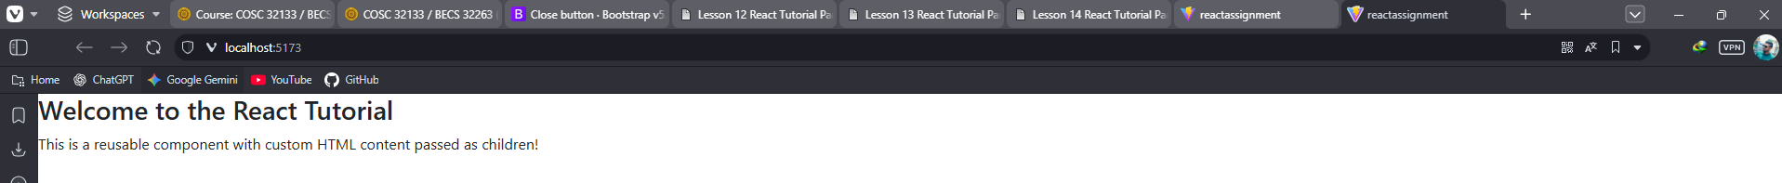
import React from "react";
interface HiProps {
children: React.ReactNode; // ReactNode allows passing HTML or other components as children
}

const Hi: React.FC<HiProps> = ({ children }) => {

const handleAlertDismiss = () => {
alert("You clicked the button! Dismissed successfully.");
};

return (
<div
className="alert alert-warning alert-dismissible fade show"
role="alert"
>
{children}
<button
type="button"
className="btn-close"
data-bs-dismiss="alert"
aria-label="Close"
onClick={handleAlertDismiss}
></button>
</div>
);
};
export default Hi;

import React from 'react';
import Hi from './components/Hi';

const App: React.FC = () => {
return (
<div>
<Hi>
<h3>Welcome to the React Tutorial</h3>
<p>This is a reusable component with custom HTML
content passed as children!</p>
</Hi>
</div>
);
};
export default App;

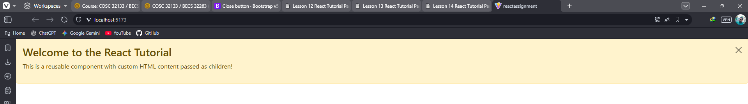
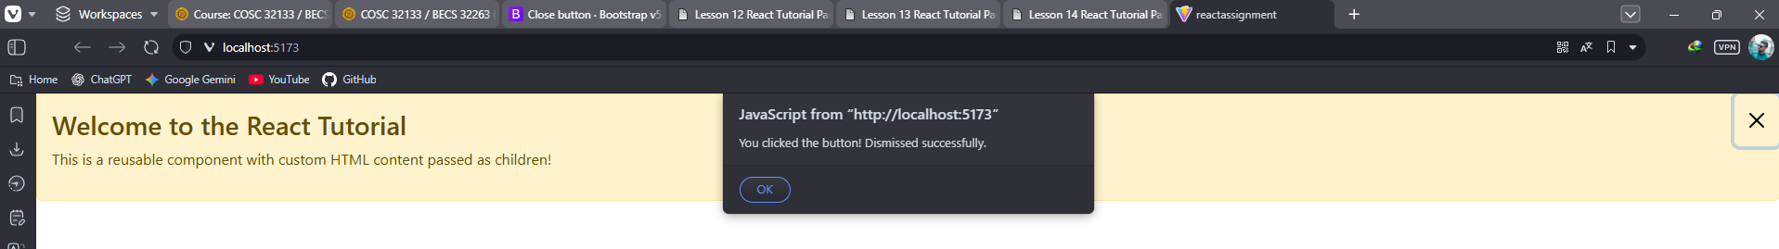

React Tutorial Part 04
import React from "react";
const ListEmployeeComponent: React.FC = () => {
const employees = [
{
id: 1,
firstname: "EC2021006Gamika",
lastname: "Jayawardhna",
email: "sandip@example.com",
},
{
id: 2,
firstname: "Navod",
lastname: "Gunasinghe",
email: "navod@example.com",
},
{
id: 3,
firstname: "Amara",
lastname: "Senarath",
email: "amara@example.com",
},
];
return (
<div className="container mt-3">
<h3 className="text-primary">Employee List</h3>
<table className="table table-bordered table-striped">
<thead className="table-dark">
<tr>
<th>ID</th>
<th>First Name</th>
<th>Last Name</th>
<th>Email</th>
</tr>
</thead>
<tbody>
{employees.map((employee) => (
<tr key={employee.id}>
<td>{employee.id}</td>
<td>{employee.firstname}</td>
<td>{employee.lastname}</td>
<td>{employee.email}</td>
</tr>
))}
</tbody>
</table>
</div>
);
};
export default ListEmployeeComponent;

import ListEmployeeComponent from './components/ListEmployeeComponent';

const App: React.FC = () => {
return (
<div>
<ListEmployeeComponent />
</div>
);
};
export default App;

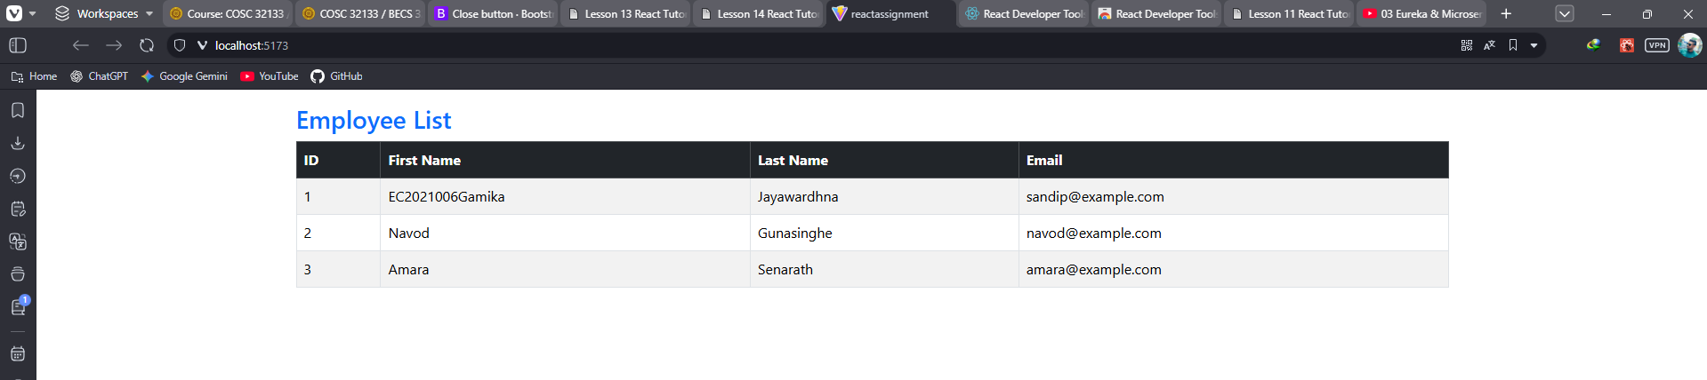

React Tutorial Part 05
import React from "react";
const Header: React.FC = () => {
return (
<nav className="navbar navbar-expand-lg navbar-dark bgprimary">
<div className="container">
<a className="navbar-brand" href="#">
Employee Management System
</a>
</div>
</nav>
);
};
export default Header;

import React from "react";
const Footer: React.FC = () => {
return (
<footer className="bg-dark text-center text-white mt-auto py3">
<div>© 2024 Employee Management System</div>
</footer>
);
};

export default Footer;

import axios from 'axios';
const API_URL = 'http://localhost:8080/api/employees'; // Replace withyour backend API URL
export const getEmployees = async () => {
const response = await axios.get(API_URL);
return response.data;
};

import React, { useState, useEffect } from 'react';
import { getEmployees } from '../services/EmployeeService';
interface Employee {
id: string;
firstName: string;
lastName: string;
email: string;
}
const ListEmployeeComponent: React.FC = () => {
const [employees, setEmployees] = useState<Employee[]>([]);
useEffect(() => {
const fetchEmployees = async () => {
try {
const data = await getEmployees();
setEmployees(data);
} catch (error) {
console.error("Failed to fetch employees.");
}
};
fetchEmployees();
}, []);
return (
<div className="container mt-3">
<h3 className="text-primary">Employee List</h3>
<table className="table table-bordered table-striped">
<thead className="table-dark">
<tr>
<th>ID</th>
<th>First Name</th>
<th>Last Name</th>
<th>Email</th>
</tr>
</thead>
<tbody>
{employees.map((employee) => (
<tr key={employee.id}>
<td>{employee.id}</td>
<td>{employee.firstName}</td>
<td>{employee.lastName}</td>
<td>{employee.email}</td>
</tr>
))}
</tbody>
</table>
</div>
);
};
export default ListEmployeeComponent;

